IDEA/APPROACH DETAILS:

Ministry Category: Students' Innovations Problem

Statement: SOFTWARE ( DEVELOPING AN EFFECTIVE E-COMMERECE MARKETINGPLACE TO BRIDGE THE VALUE GAP BETWEEN THE FARMERS-MANUFATURERS-CONSUMERS )

Team Leader: Vedanth Padigelwar

Problem Code: #SIC6

College ID: #9377

**From Seeds of Suicide to Seeds of Hope**

**PROBLEM STATEMENT** : Developing an effective e-commerce marketplace to bridge the value gap between farmers - manufactures –consumers

* In the last 20 years, nearly 300,000 farmers have ended their lives by ingesting pesticides or by hanging themselves.
* In a country where agriculture remains the largest employment sector where share of agriculture in employment was **48.9 per cent of the workforce, agriculture accounted only for 17% of the GDP** .
* **Agriculture's contribution to GDP has steadily declined from 1951 to 2011**, yet it is still the country's largest employment source and a significant piece of its overall socio-economic development.

From the above statistics it is very clear that there is a fundamental change required in the current system in agriculture. The rising cost of food in the past year is often blamed on **a multi-layered system of middlemen involved in the distribution of produce from farm to fork**. India’s poor infrastructure in crop producing regions also enables middlemen to deceive farmers as to the true value of the produce they are selling.

A farmer’s biggest tension is whether his produce will sell, and if it does, will he make enough to recover the amount that went into making the produce “**The intermediaries add value but they increase the cost. You need to provide the farmer an alternative avenue to sell their produce**”.

**OUR SOLUTION**

We will be building a **platform that will function as a market place and supply chain.**

There are a couple of problems which we have to address to lead to a more effective system compared to our current system.

1. A **reliable market place** which can act as an interface between farmer and buyer eliminating the middlemen
2. **Absence of proper grading system** to know the quality of the material before hand.
3. An **effective transportation** system
4. A **transparent money transaction** system

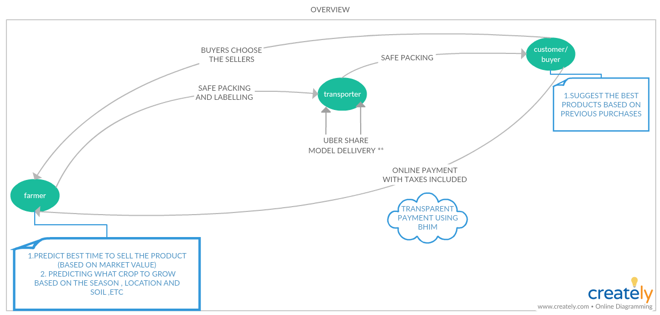

1. **RELIABLE MARKET PLACE**
   1. **FARMER’S POINT OF VIEW**

* It all starts with the farmer signing up in the app using his **Aadhaar card verification**.
* He will be shown a couple of question which includes the soil climate and permission to access to his location for later analysis for various predictions.
* Once a farmer wants to sell a product he can **put up his product and the amount of product** he has and the price per quantity. Thus making it easier for the farmer to sell his product.
* In addition to this **farmer will be given suggestion of best crop to grow** based the current conditions of the area by our algorithm.
* Similarly suggestion for the **best time to sell the product to get maximum value** out of the product
  1. **BUYER’S POINT OF VIEW**
* Once buyer searches for a product , a list of available farmers along with the price and the farmer’s rating based on the previous products that the farmers sold.
* The buyers will also be shown **a list of logistics available which is near by the farmer** to transport his goods.

This is an effective marketplace which helps in the interaction between farmers and the buyers thus eliminating the middlemen.

1. **Absence of proper grading system to know the quality of the material before hand.**

* As a general rule, there is hardly any grading of the commodities to be marketed. Therefore, the purchaser has little, if any, confidence in the quality of the product(s).
* This brings us to the second part of building a **multilayer grading system** that is unlike the conventional grading systems which we see in all the existing e-commerce product. The **rating will be based on different aspects** of the products like quality , punctuality, packing of the product. Thus making it **easier for the buyer to decide between products**.

1. **An effective transportation system**

* In the Uber app, you select Uber Pool and enter your destination. Once you have selected your destination you will see the amount charged for the ride.
* If you accept, the request will go to all nearby cab drivers and when one of them accepts the ride. If there is a co-passenger travelling with you, his or her name will also be displayed. However, you can't see where your co-passenger is going.
* Same way we can implement it in our transport system. We could **transport multiple items in a similar manner.** Over here the **cab drivers will be the logistic people, passengers will be the items that are being sold from one place to another.**

1. **A transparent money transaction system**

* Contributing to digital India , with the help of BHIM app integrated to our app , the transaction can be made transparent at every level, thus making it foolproof.
* This will further help in surveys and other analysis in future

FUTURE PLANS :

**Technology Stack:**

**Server Side:**

* Operating System
* Database
* Programming Language

**User's Phone:**

* Native Application (Interface)

**FRAMEWORK: LANGUAGE:**

1. Numpy Python

Pycharm

Keras(Neural Nets)

2. Android Studio Java

3. Matlab Matlab

4. Express.JS Node.js

**A small touch of TECHNOLOGY**

|  |  |  |
| --- | --- | --- |
| **Technology** | **What it does** | **Final outcome** |
| Machine learning (neural networks) | * Predict what crop to grow at a particular time * Predict the best time to sell the crop to get maximum market value * Giving suggestions for the buyers based on his previous purchases | * Help telling at a given time best crop for the soil and the season * Based on previous year’s sales report of the product and market values , to help farmers get the best price |
| Database System | Information of all the farmers , Logistics and the buyers  Stored. | This can be used by government for surveys and  Accountings. |
| Location and Transportation (Uber , Ola algorithm implementation) | The algorithm dynamically adapts the route, basis the first commuter's pick-up and drop-off point, as the main route and the following bookings are matched accordingly, in real time. | The system resulting in effective usage of transportation system |
| App and web | App to provide beautiful front end and web for the back end | App help in reaching out more people and making the interaction easier |
| Digital Payment System | The BHIM app from govt. of India is great for the payment  system | This will allow to make the payment system transparent and corruption free and foolproof |

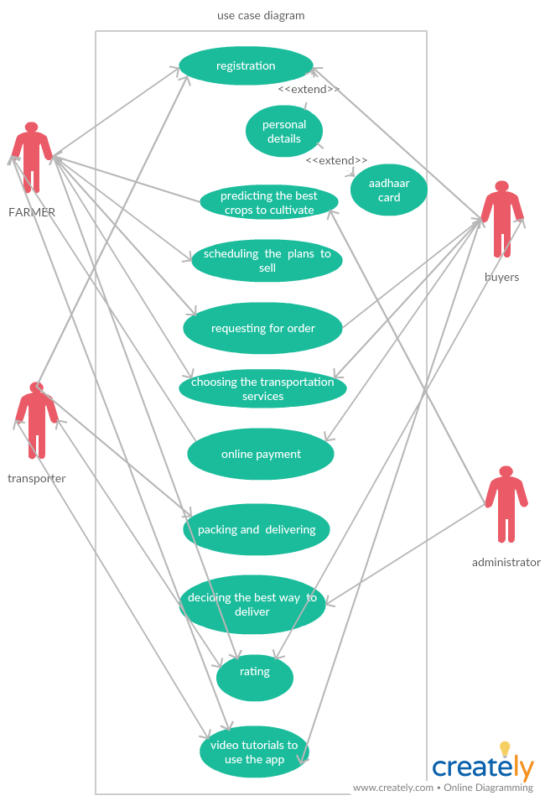

Dependencies and Show Stoppers

1. Since we predict the time that it is best for the farmers to sell their crops .The problem that occurs is that most farmers don’t have good storage facilities.

The solution we propose is to build Government owned warehouses, where farmers can store their crops in a much efficient way. They could make a society among themselves and manage the warehouses.

2. The second hurdle that we could face is the fact, that most of the farmers of our country are illiterate, hence they wouldn’t know how to use the app .

The solution we propose for this is, that make the farmers educated about using the app by holding government camps in villages , by radio or television advertisements .Hence the famers would use the app in an effective way.